CSI (correct amount)

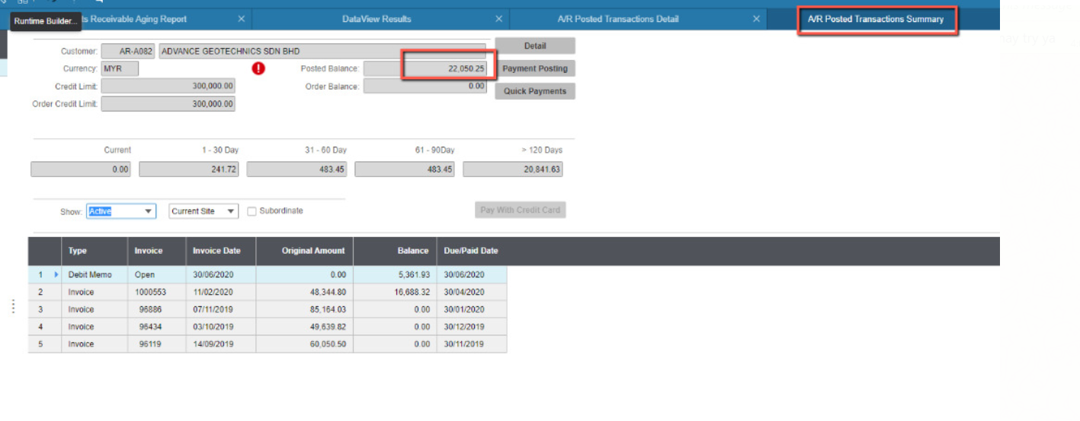

Dotnet (missing nov transaction )

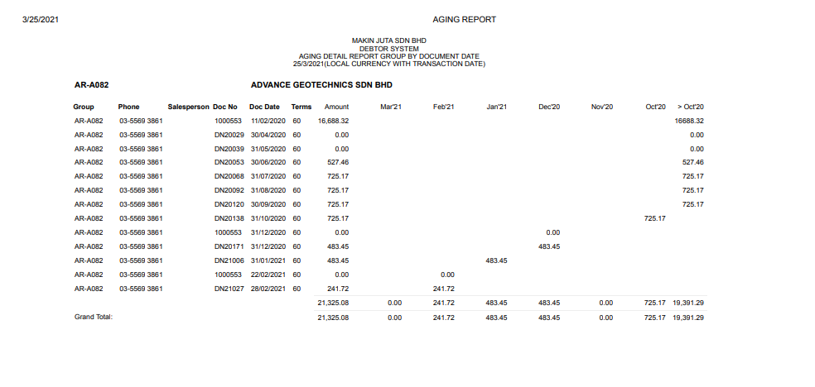

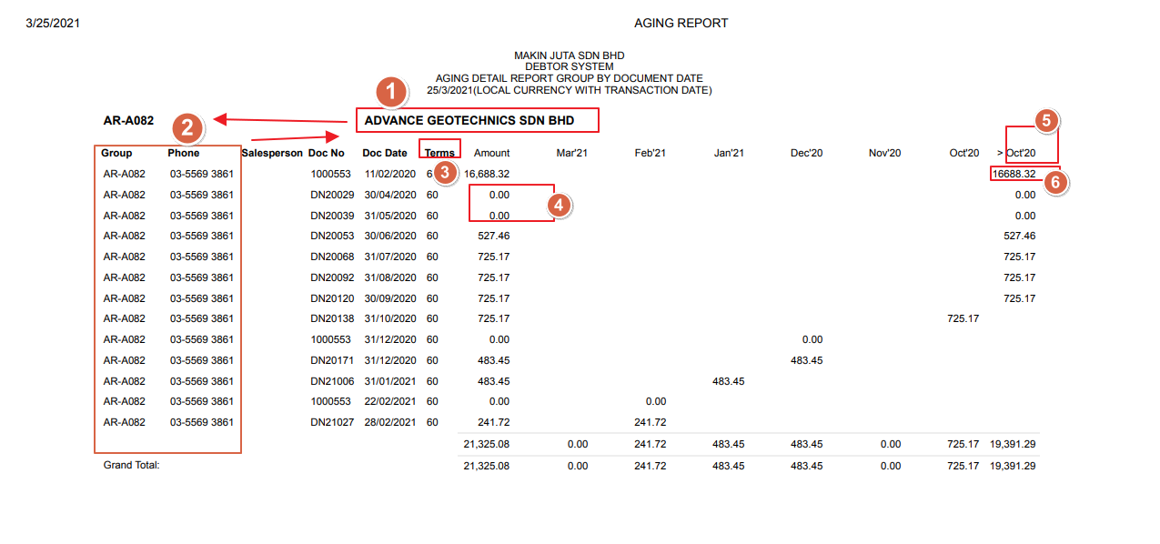

1. (1)Move to the left.
2. (2) move up
3. (3) change to due date
4. (4) remove all 0.00
5. (5) oct change to September
6. (6) all the amount need to have , ( 16,688.32)

The data from the excel is correct , but didn’t capture in the dotnet system.

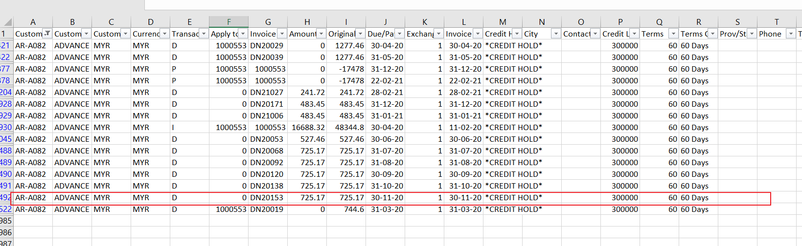

Sample

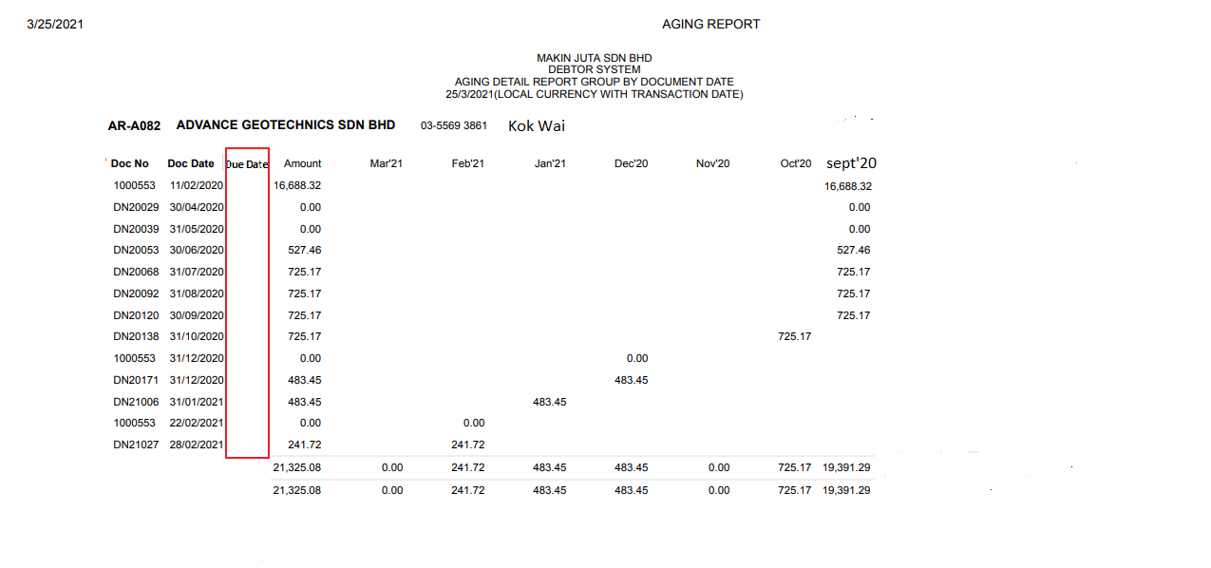

Due date capture from

